Orthodox Christianity (Russian: Православие Pravoslavije) is Russia's traditional and largest religion, deemed a part of Russia's "historical heritage" in a law passed in 1997.
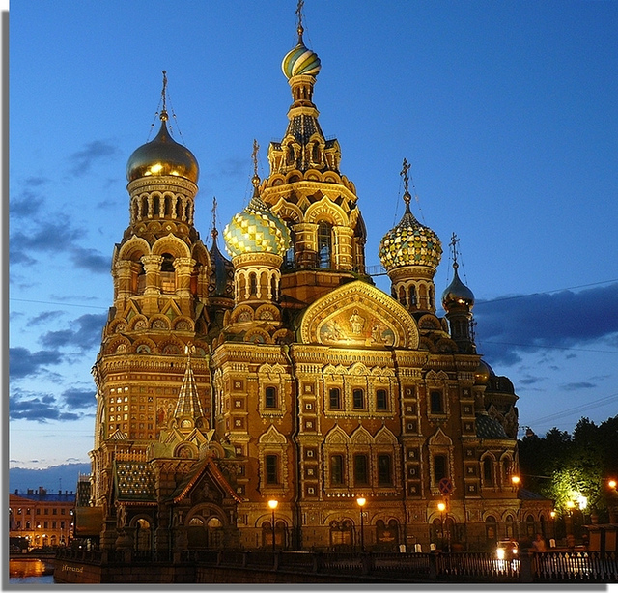

Russia's government type is a Federation (The Russian Federation). The current head of government is Vladimir Putin.
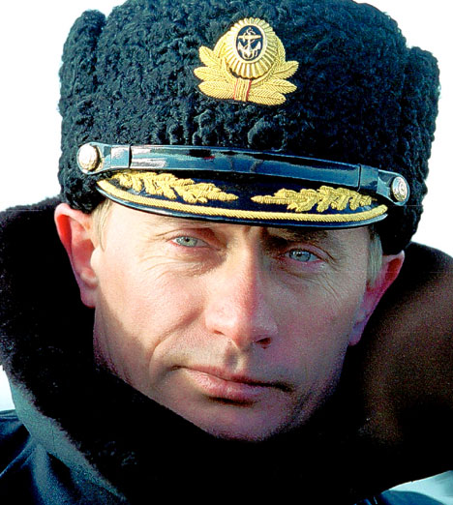
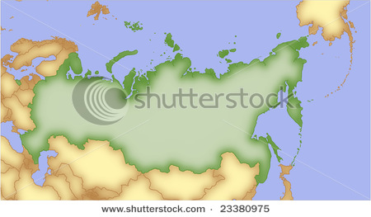
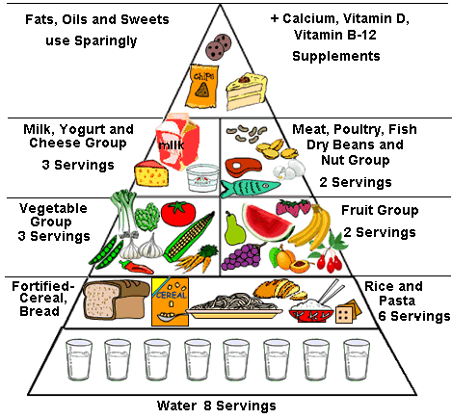
141,750,000
22 people per square mile

Russia is mainly a northern country with long-lasting cold winter. The food has to give the people eating it a lot of energy and warmth to survive during the winter time. So, the essential components of Russian cuisine are the ones which provide more carbohydrates and fat rather than proteins. Fresh fruits and vegetables are rarely used in food. So, the top five components of a Russian meal are potatoes, bread, eggs, meat (especially beef) and butter. Other popular foods include cabbage, milk, sour cream, curds, mushrooms, lard, cucumbers, tomatoes, apples, berries, honey, sugar, salt, garlic, and onions.
